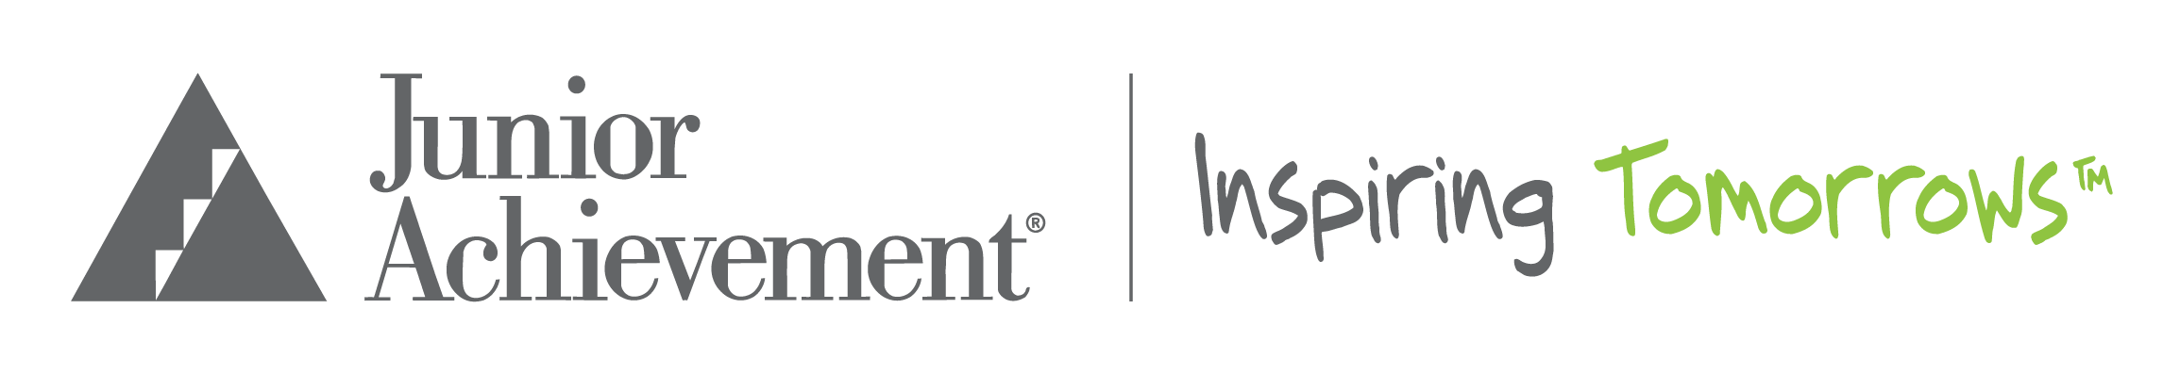

Junior Achievement of Tampa Bay 2021 Scholarship Opportunities
Deadline to apply: Wednesday, March 31, 2021

Scholarships are a unique way to say, "We believe in our students." Through the generosity of sponsors, the following scholarship opportunities are available to high school seniors who have participated in Junior Achievement programs sometime during 6-12th grade and plan on attending post-secondary education in Florida.

RENEWABLE FOUR YEAR OPPORTUNITIES:

Pam and Les Muma
One award of a 4 year renewable scholarship for a total of $5,500 for a Tampa Bay area high school senior whose plans are to attend a 4 year college or university. The scholarship is awarded on a schedule of $2,500 the first year with $1,000 renewable scholarship available based on meeting eligibility requirements for years 2-4 for a total of $5,500.

Michael D. Robertson
One award of a 4 year renewable scholarship for a total of $5,500 for a Tampa Bay area high school senior whose plans are to attend an accredited technical/vocational school, community college or 4 year university. The scholarship is awarded on a schedule of up to $2,500 the first year with $1,000 renewable scholarship available based on meeting eligibility requirements for years 2-4 for a total of $5,500.

ANNUAL OPPORTUNITIES:
Frances and Gus Stavros
One award for $2,500 for a Tampa Bay area high school senior whose plans are to attend an accredited technical/vocational school, community college or 4 year university.

Scholarship awards are paid directly to the institution recipient will be attending and can be utilized for:
- college tuition
- room and board
- books, computer and/or computer software

Who can be a Junior Achievement Scholarship Recipient?

Requirements are:
- participated in Junior Achievement programs between 6-12th grade
- obtain a high school diploma or GED
- intentions to attend a post-secondary institution in the state of Florida
- submit proof of current GPA from an official high school transcript photo copy/screen shots are acceptable with name of student and school
- submit proof of SAT or ACT scores photocopy/screen shots are acceptable from accredited source verifying scores
- minimum cumulative GPA of 2.5
- completed application essay

Application Essay
Applicants must submit a 1000 word essay containing the following information:
- who you are as a person
- the impact that Junior Achievement has had on your personal development
- challenges you have had to overcome and how JA helped you overcome them
- the impact that the JA volunteer has had on you
- if you have volunteered for Junior Achievement at various events and/or in the classroom, how many times, the impact that being a Junior Achievement volunteer/student ambassador has had on you
- Why are you deserving of a Junior Achievement Scholarship?

Scholarship Application deadline is Wednesday, March 31, 2021

Apply on-line to: JA Scholarship Application

Application Questions, contact Dawn Brabson at dawn.brabson@ja.org

